Ministerul Educaţiei, Tineretului şi Sportului al Republicii Moldova

Universitatea Tehnică a Moldovei

Facultatea Calculatoare, Informatică şi Microelectronică

Demaptamentul Informatică și Ingineria Sistemelor

# RAPORT

Lucrare de laborator nr.3

la Analiza şi Sinteza Dispozitivelor Numerice

Tema: Sinteza decodificatoarelor si codificatoarelor

A efectuat: Cojocari Dragos,TI-214

A verificat: asistent univ.

Ursu Adriana

Chişinău 2022

Tema: Sinteza convertoarelor de cod

1.Efectuaţi sinteza unui decodificator complet cu trei variabile de intrare.

2.Efectuaţi sinteza unui decodificator binar-zecimal (8 4 3 (-2))

3.Efectuaţi sinteza unui codificator binar-zecimal (4 3 2 1)

4.Se verifica corectitudinea functionarii circuitelor integrate ale standului de laborator.

5.Se asambleaza si se regleaza schema unui decodificator binar-zecimal din tema pentru acasa in setul de elemente SI-NU.

Codul binar-zecimal intrare: 8 4 3 (-2)

Codul binar-zecimal ieşire: 4 3 2 1

Tabel de adevar

|  |  |  |  |  |  |  |  |  |  |  |  |  |  |  |  |  |  |
| --- | --- | --- | --- | --- | --- | --- | --- | --- | --- | --- | --- | --- | --- | --- | --- | --- | --- |
| 8 | 4 | | 3 | | -2 | | |  |  | |  |  |  |  |  |  |  |
|  | 𝒙𝟏 | | 𝒙𝟐 | | 𝒙𝟑 | 𝒙𝟒 |  | Y0 | Y1 | | Y2 | Y3 | Y4 | Y5 | Y6 | Y7 | Y8 | Y9 |
| 0 | 0 | | 0 | | 0 | 0 |  | 1 | 0 | | 0 | 0 | 0 | 0 | 0 | 0 | 0 | 0 |
| 1 | 0 | | 0 | | 1 | 1 |  | 0 | 1 | | 0 | 0 | 0 | 0 | 0 | 0 | 0 | 0 |
| **2** | 0 | | 1 | | 0 | 1 |  | 0 | 0 | | 1 | 0 | 0 | 0 | 0 | 0 | 0 | 0 |
| 3 | 0 | | 0 | | 1 | 0 |  | 0 | 0 | | 0 | 1 | 0 | 0 | 0 | 0 | 0 | 0 |
| **4** | 0 | | 1 | | 0 | 0 |  | 0 | 0 | | 0 | 0 | 1 | 0 | 0 | 0 | 0 | 0 |
| **5** | 0 | | 1 | | 1 | 1 |  | 0 | 0 | | 0 | 0 | 0 | 1 | 0 | 0 | 0 | 0 |
| **6** | 1 | | 0 | | 0 | 1 |  | 0 | 0 | | 0 | 0 | 0 | 0 | 1 | 0 | 0 | 0 |
| **7** | 0 | | 1 | | 1 | 0 |  | 0 | 0 | | 0 | 0 | 0 | 0 | 0 | 1 | 0 | 0 |
| **8** | 1 | | 0 | | 0 | 0 |  | 0 | 0 | | 0 | 0 | 0 | 0 | 0 | 0 | 1 | 0 |
| **9** | 1 | | 0 | | 1 | 1 |  | 0 | 0 | | 0 | 0 | 0 | 0 | 0 | 0 | 0 | 1 |
|  |  | |  | |  |  |  |  |  | |  |  |  |  |  |  |  |  |
| **10** | 0 | | 0 | | 0 | 1 |  | * | * | | * | * | * | * | * | * | * | * |
| **11** | 1 | | 0 | | 1 | 0 |  | * | * | | * | * | * | * | * | * | * | * |
| **12** | 1 | | 1 | | 0 | 0 |  | * | * | | * | * | * | * | * | * | * | * |
| **13** | 1 | | 1 | | 0 | 1 |  | * | * | | * | * | * | * | * | * | * | * |
| **14** | 1 | | 1 | | 1 | 0 |  | * | * | | * | * | * | * | * | * | * | * |
| **15** | 1 | | 1 | | 1 | 1 |  | * | * | | * | * | * | * | * | * | * | * |

2.Minimizarea functiilor:

|  |  |  |  |  |
| --- | --- | --- | --- | --- |
| x1x2  x3x4 | 00 | 01 | 11 | 10 |
| 00 | y0 | y4 | * | y8 |
| 01 | * | y2 | * | y6 |
| 11 | y1 | y5 | * | y9 |
| 10 | y3 | y7 | * | * |

y0= 𝑥̅1𝑥̅2𝑥̅3

y1= 𝑥̅1𝑥̅2𝑥4

y2= 𝑥2𝑥̅3𝑥4

y3= 𝑥̅2𝑥3𝑥̅4

y4= 𝑥2𝑥̅3𝑥̅4

y5= 𝑥2𝑥3𝑥4

y6= 𝑥1𝑥̅3𝑥4

y7= 𝑥2𝑥3𝑥̅4

y8= 𝑥1𝑥̅3𝑥̅4

y9= 𝑥1𝑥3

ȘI-NU

y0= 𝑥̅1𝑥̅2𝑥̅3

y1= 𝑥̅1𝑥̅2𝑥4

y2= 𝑥2𝑥̅3𝑥4

y3= 𝑥̅2𝑥3𝑥̅4

y4= 𝑥2𝑥̅3𝑥̅4

y5= 𝑥2𝑥3𝑥4

y6= 𝑥1𝑥̅3𝑥4

y7= 𝑥2𝑥3𝑥̅4

y8= 𝑥1𝑥̅3𝑥̅4

y9= 𝑥1𝑥3

**Schema decodificatorului binar-zecimal:**

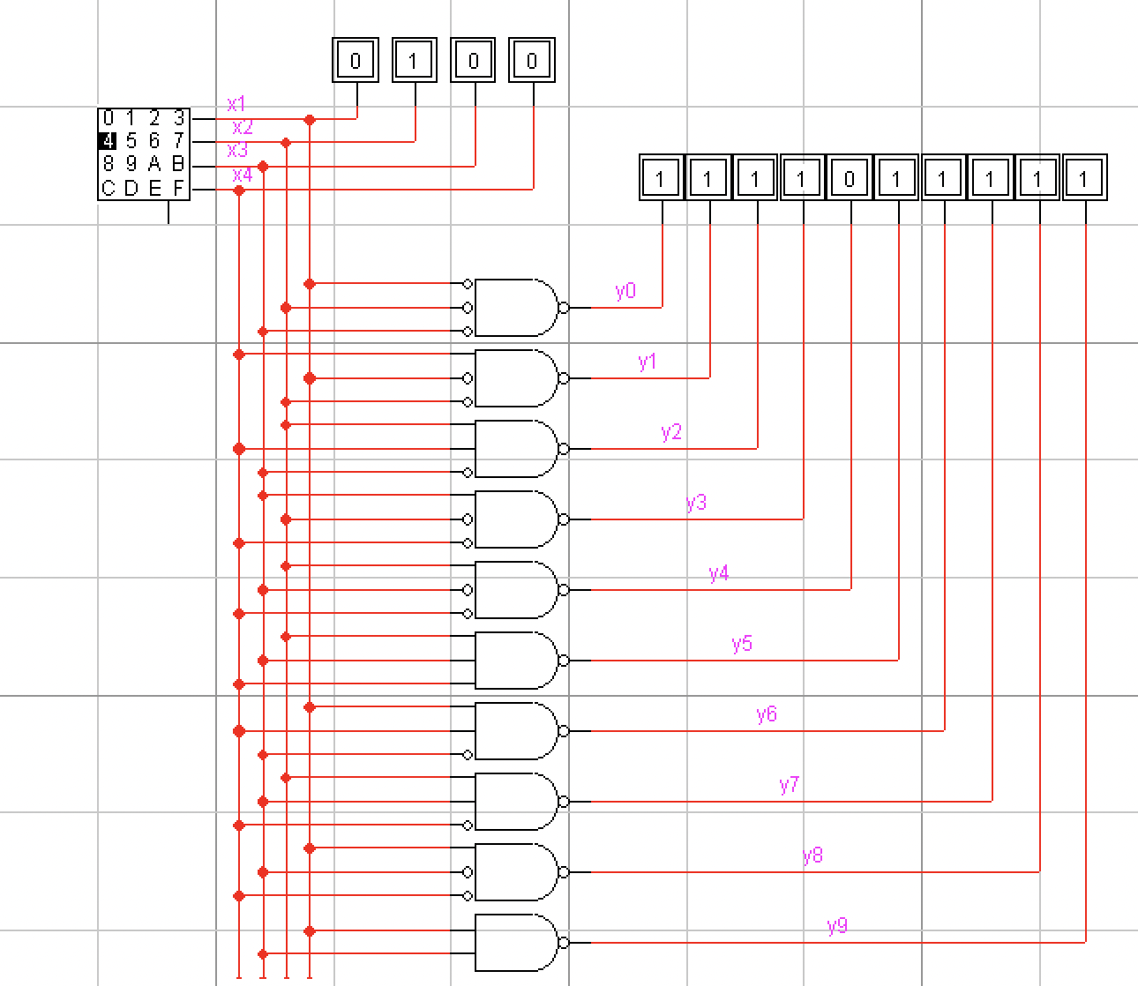

**Schema de timp:**

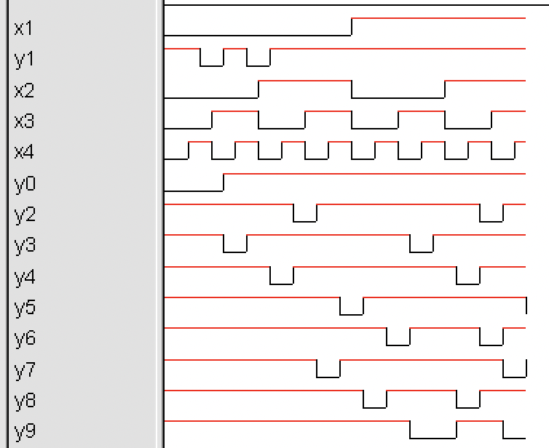

**Tabelul de adevăr al codificatorului binar-zecimal: 4 3 2 1**

|  |  |  |  |  |  |  |  |  |  |  |  |  |  |  |  |  |  |  |  |  |  |
| --- | --- | --- | --- | --- | --- | --- | --- | --- | --- | --- | --- | --- | --- | --- | --- | --- | --- | --- | --- | --- | --- |
|  |  | |  | |  |  |  | |  | | |  | |  | |  | | 4 | 3 | 2 | 1 |
|  | **𝒙0** | | **𝒙1** | | **𝒙2** | **𝒙3** | **𝒙4** | | **𝒙5** | | **𝒙6** | **𝒙7** | | **𝒙8** | | **𝒙9** | |  | **f1** | **f2** | **f3** | **f4** |
| 0 | 1 | | 0 | | 0 | 0 | 0 | | 0 | | 0 | 0 | | 0 | | 0 | |  | 0 | 0 | 0 | 0 |
| 1 | 0 | | 1 | | 0 | 0 | 0 | | 0 | | 0 | 0 | | 0 | | 0 | |  | 0 | 0 | 0 | 1 |
| **2** | 0 | | 0 | | 1 | 0 | 0 | | 0 | | 0 | 0 | | 0 | | 0 | |  | 0 | 0 | 1 | 0 |
| 3 | 0 | | 0 | | 0 | 1 | 0 | | 0 | | 0 | 0 | | 0 | | 0 | |  | 0 | 0 | 1 | 1 |
| **4** | 0 | | 0 | | 0 | 0 | 1 | | 0 | | 0 | 0 | | 0 | | 0 | |  | 0 | 1 | 0 | 1 |
| **5** | 0 | | 0 | | 0 | 0 | 0 | | 1 | | 0 | 0 | | 0 | | 0 | |  | 1 | 0 | 0 | 1 |
| **6** | 0 | | 0 | | 0 | 0 | 0 | | 0 | | 1 | 0 | | 0 | | 0 | |  | 1 | 0 | 1 | 0 |
| **7** | 0 | | 0 | | 0 | 0 | 0 | | 0 | | 0 | 1 | | 0 | | 0 | |  | 1 | 1 | 0 | 0 |
| **8** | 0 | | 0 | | 0 | 0 | 0 | | 0 | | 0 | 0 | | 1 | | 0 | |  | 1 | 1 | 0 | 1 |
| **9** | 0 | | 0 | | 0 | 0 | 0 | | 0 | | 0 | 0 | | 0 | | 1 | |  | 1 | 1 | 1 | 0 |

**Setul de funcții care realizează codificatorul din tabelul de mai sus:**

*f1* = x5 + x6 + x7 + x8 + x9

*f2* = x4 + x7 + x8 + x9

*f3* =x2 + x3 + x6 + x9

*f4* = x1 + x3 + x4 + x5 + x8

**NAND**

*f1* = 𝑥̅5 + 𝑥̅6 + 𝑥̅7 + 𝑥̅8 + 𝑥̅9

*f2* = 𝑥̅4 + 𝑥̅7 + 𝑥̅8 + 𝑥̅9

*f3* = 𝑥̅2 + 𝑥̅3 + 𝑥̅6 + 𝑥̅9

*f4* = 𝑥̅1 + 𝑥̅3 + 𝑥̅4 + 𝑥̅5 + 𝑥̅8

**Schema codificatorului binar-zecimal: 4 3 2 1**

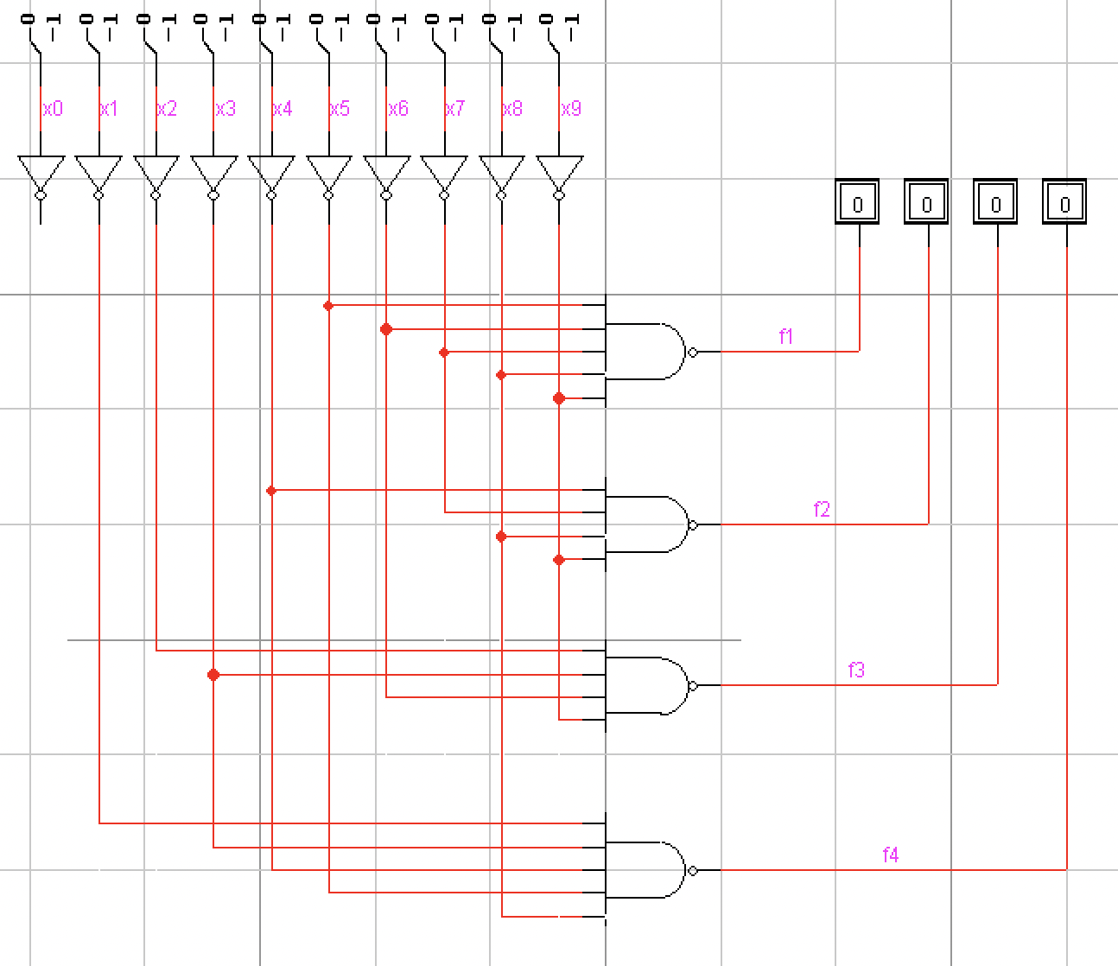

**Schema de timp**

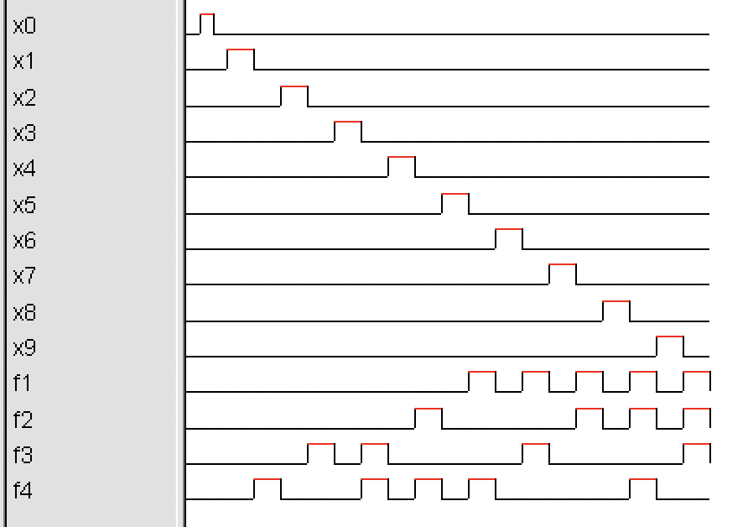

**Concluzie:** În urma efectuarii de laborator am luat cunoștință cu codificatorul-zecimal și decodificatorul-zecimal, am conștientizat cum putem codifica și decodifica diferite coduri la necesitate. Cu ajutorul programului LogicWorks am avut posibilitatea de a le crea și a observa cum lucrează în practică.